The code for displaying a letter ( in our case 'A' ) :

#include "lm3s9b92.h"

void timerConfig(void)
{
int waitcycle=0;
// configure Timer 0
SYSCTL_RCGC1_R |= (1<<16);
waitcycle++; // wait for timer 0 activation
TIMER0_CTL_R &= ~0x0001; // disable Timer 0
TIMER0_CFG_R = 0x04; // 2 x 16-bit mode
TIMER0_TAMR_R = 0x22; // periodic mode + match enable
TIMER0_TAPR_R = 30-1; // prescaler PR= ceil(16000000/2^16*0.12)-1
}

void timerWait(unsigned short usec) //usec is the value in µs after which the timer reaches time-out.
{

TIMER0_TAILR_R= (usec*16)/29; // Set the interval load value
TIMER0_CTL_R |= 0x0001; // Enable the timer
while((TIMER0_RIS_R & (1<<0))==0); // Wait for the time-out flag of the timer to be set.
TIMER0_ICR_R |= (1<<0); //clear the interrupt flag that was set previously.
TIMER0_CTL_R &= ~0x0001; //disable the timer
}

int main(void)
{
int i,waitcount=0;
int ar[]= {0xFE,0x90,0x90,0x90,0xFE}; // Create the array of patterns

timerConfig();// Configer TIMER0

SYSCTL_RCGC2_R = (1<<3)|(1<<4) ;// Enable clock for port D and E
waitcount++;

GPIO_PORTE_DIR_R = 0x00;// Set port E as an input
GPIO_PORTE_DEN_R = 0x01;// Enable port E
waitcount++;

GPIO_PORTD_DIR_R = 0xFF;// Set PORTD as an output

GPIO_PORTD_DEN_R = 0xFF;//Enable Port D

while(1){
while(!(GPIO_PORTE_DATA_R && 0x01)){ } //wait until it's at the left margin

timerWait(31500); // wait 31.5 miliseconds before starting to print the array patterns
for(i=0;i<5;i++)
{
GPIO_PORTD_DATA_R=ar[i];// print pattern i from the array
timerWait(1500);// wait 1.5 miliseconds before printing next pattern from the array
};

GPIO_PORTD_DATA_R=0x00;// set Port D bits to 0 in order not to show anything
while(GPIO_PORTE_DATA_R && 0x01){ }// wait for the right margin
}
}

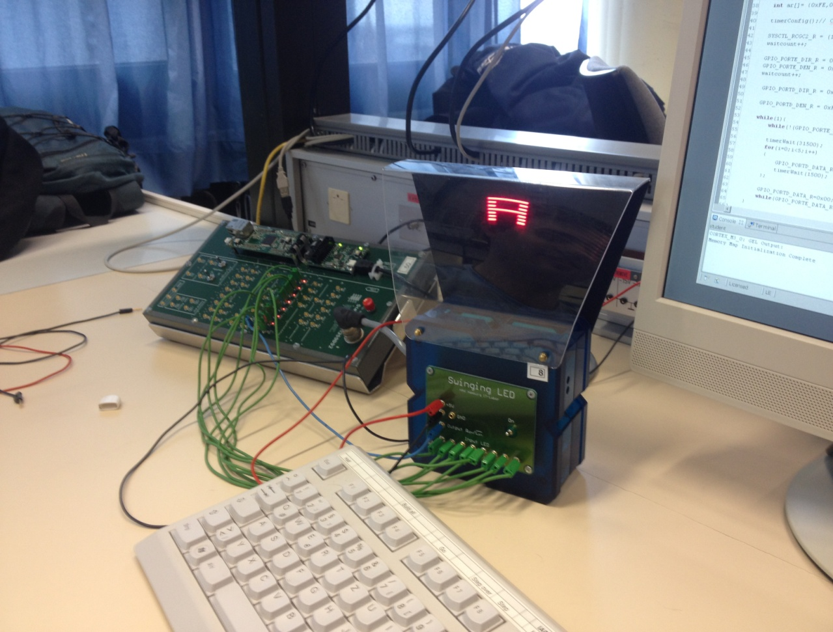

The code to display the string "LAB":

#include "lm3s9b92.h"

int main(void)
{
int i,waitcount=0;
int ar[]= {0xFE,0x02,0x02,0x02,0x02,0x00,0xFE,0x90,0x90,0x90,0xFE,0x00,0xFE,0x92,0x92,0xAA,0xC6};
// Create the array of patterns

timerConfig();// Configer TIMER0A

SYSCTL_RCGC2_R = (1<<3)|(1<<4) ;// Enable clock for port D and E
waitcount++;

GPIO_PORTE_DIR_R = 0x00;// Set port E as an input
GPIO_PORTE_DEN_R = 0x01;// Enable port E
waitcount++;

GPIO_PORTD_DIR_R = 0xFF;// Set PORTD as an output

GPIO_PORTD_DEN_R = 0xFF;//Enable Port D

while(1){
while(!(GPIO_PORTE_DATA_R && 0x01)){ } //wait until it's at the left margin

timerWait(21000);// wait 21 miliseconds before starting to print the array patterns
for(i=0;i<17;i++)
{
GPIO_PORTD_DATA_R=ar[i];//print pattern i from the array
timerWait(1500);//wait 1.5 miliseconds before printing next pattern from the array
};

GPIO_PORTD_DATA_R=0x00;//set Port D bits to 0 in order not to show anything
while(GPIO_PORTE_DATA_R && 0x01){ }// wait for the right margin
}
}
